Lab Write Up Format
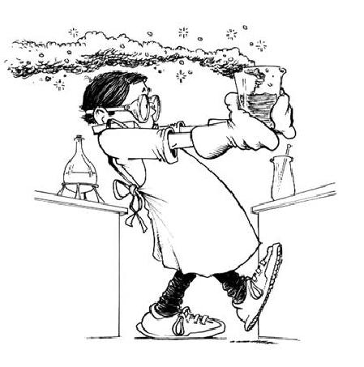
Every Lab Write Up Should Include:
Title Problem
Hypothesis Procedure
Data Conclusion

Title: This should be written across the top of your page. It should be a brief statement reflecting the topic of the experiment. It should also include the section number associated with the lab.

Problem: This is the purpose of the investigation and is ALWAYS written in the form of a question.

Hypothesis: This answers the investigative question from your problem. It should always be written in the following format:
“If… then… because…”
The “if” is what is being done.
“If a gummy bear is put in water overnight…”

The “then” statement is your prediction for the outcome of the experiment. What will happen to the variable being measured when you change a variable in some way.
“then the bear will dissolve,…”

The “because” statement is your reasoning why. It’s the explanation of the change.
“because sugar dissolves in water and gummy bears are made of sugar.”

NO “I”, “ME”, or “MY” Statements are allowed! No personal pronouns!

Procedure: This should be written as numbered steps. Describe step-by-step what is being done in the experiment. Your procedures should show setting up, measuring, and recording of data with repeated trials. (Mrs. D rarely requires the procedure to be written out!)

Data: Data collected should be presented in a data table format. It should be organized and written neatly. Usually the format for this will be given to you by your teacher.

Conclusion: This should consist of two paragraphs. The first paragraph should include:
- Whether the data supported or did not support the hypothesis. (No wrong/right, correct/incorrect allowed!)
- A restatement of your hypothesis. “The hypothesis stated that….”
- At least two specific facts from your collected data that support or disprove the hypothesis. Explain how this data does or does not support the hypothesis.
The second paragraph should include two points: any limitations or errors that may have occurred to alter the results of the experiment, and how this experiment related to what we have been studying in class.

